# Nu med titel

File -> Clone / New

<https://github.com/Netimage/NT-App-Android>

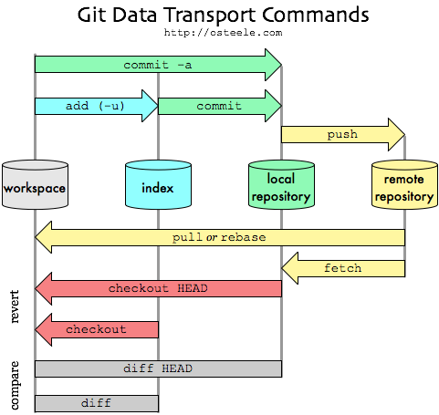

Branching / Git flow

Update version.properties -> Commit -> Push

Merging -> Merge conflict

Reverse Commit